**Healthy Pork Chop Recipes**

A pork chop is more than just a pork chop. It is our equal of beefsteak and is one of the most wonderful of our food discoveries. There are various kinds of pork chops. These are mainly dependent on the cut of meat and whether they are mild tasting or tender. The meat could also be tough or need braising, but at the same time turn out to be very flavorful.

It is important to remember that pork chops are very healthy. This is because they come from the loins of pigs and also contain the tenderloin. The most common pork chops come from the ribs and the loin. Shoulder chops are also conventional and are frequently known as blade chops and blade steaks.

There are various ways to cook pork chops. Different pieces, from different parts of the pig, have their cooking methodology. Let’s discuss a couple of them in this article.

**#1 Mango Salsa Pork Chops**

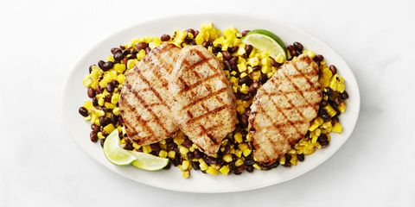

**Image Source-**  <https://www.goodhousekeeping.com/food-recipes/g333/pork-chop-recipes/?slide=1>

This is a relatively easy recipe. You have to start by grilling corn for eight minutes. It is better if the corn is very slightly charred. Take all the kernels off the cob of corn.

Take large plastic wraps and gently cover the pork chops with them. Take a meat mallet or rolling pin and pound the meat to ¼'' thickness. Brush olive oil, over the meat, and then sprinkle with salt and chili powder. Grill the pork on medium-high for 2 minutes, each side.

Put together some black beans, mango, and corn kernels. Add ½ teaspoon of salt and pepper. Serve pork with salsa and lime wedges.

**#2 Apples and Balsamic Braised Cabbage Pork Chops**

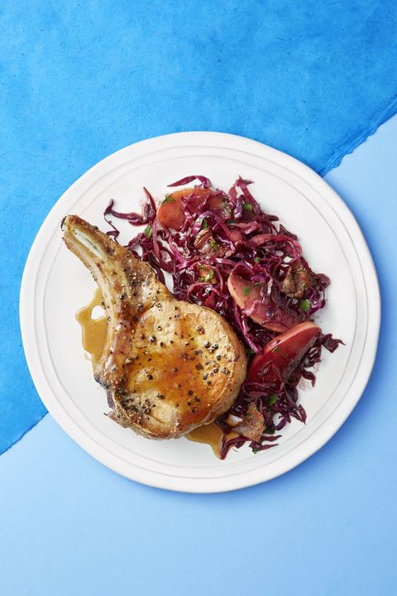

**Image Source-** <https://www.goodhousekeeping.com/food-recipes/g333/pork-chop-recipes/?slide=1>

Cook your bacon, ideally in a Dutch oven in medium heat, until its crisp. Transfer it to a paper towel. Add caraway seeds and onion. Cook them together for a good six minutes. Next, take some gala apple, cut into ½ inch pieces along with some balsamic vinegar and cabbage. Also, add ¼ teaspoon pepper and ½ teaspoon kosher salt.

Cover and cook for six to eight minutes while stirring occasionally. Season your pork chops with ½ teaspoon of salt and pepper. Heat some oil in an iron skillet on medium-high and cook your pork until its brown 2-3 minutes each side. Take some parsley and reserved bacon for folding into your cabbage. Serve with pork.

**#3 Ginger Pork With Cucumber Salad**

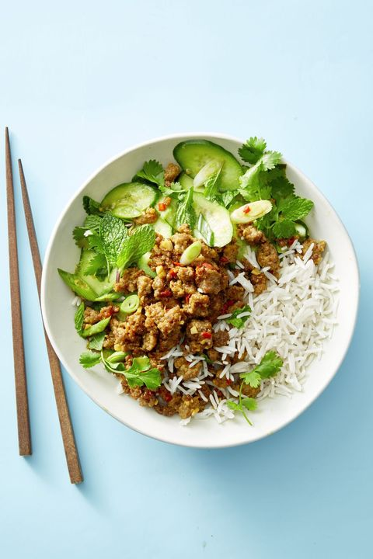

**Image Source-** <https://www.goodhousekeeping.com/food-recipes/g333/pork-chop-recipes/?slide=1>

Take some canola oil in a skillet. Brown ground pork chop in it for seven minutes. Toss it along with red chili, garlic, and two tablespoons of fresh, grated ginger. Take it off the heat and then toss with one tablespoon of soy sauce (preferably low-sodium) and two tablespoons of lime juice.

Next, you need to whisk together two tablespoons of lime juice, ½ tablespoon of grated ginger, another tablespoon of low-sodium soy sauce, and brown sugar. Toss it along with scallions and cucumber, and then fold with cilantro as well as mint. Top rice with pork and serve.

**#4 Pickled Carrot and Caramel Pork Chops**

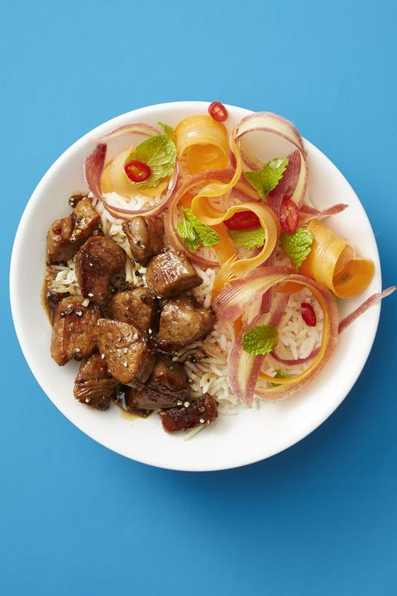

**Image source-** <https://www.goodhousekeeping.com/food-recipes/g333/pork-chop-recipes/?slide=1>

Take rice vinegar, ¼ teaspoon salt, and rice vinegar in a bowl and whisk it together. Use a vegetable peeler to shave long ribbons out of carrots. Next, add red chili and allow it to sit, occasionally tossing for 20 minutes. Fold in a mint after draining the liquid.

Whisk together chicken broth, fish sauce, and ¼ cup of brown sugar. The season you pork with ¼ pepper and salt. Keep a skillet on high and heat one tablespoon oil in it. Add pork to it and cook for 2-8 minutes until it turns brown on all sides. To the mix, add broth and boil. Reduce heat and simmer till sugar dissolves. After 2-3 minutes, add pork and cook for 1 minute. Serve with rice and pickled carrots.

**#5 Shredded Citrus Pork**

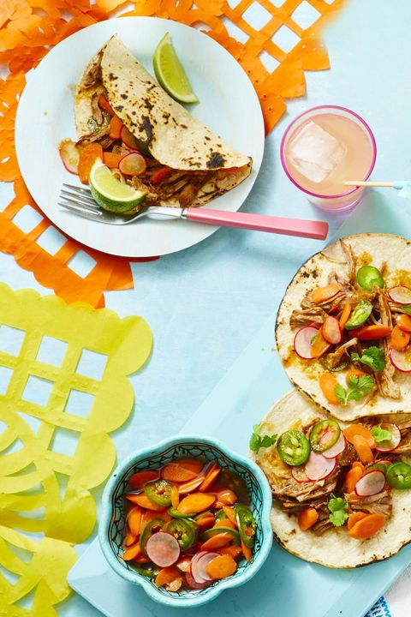

**Image Source-** <https://www.goodhousekeeping.com/food-recipes/g333/pork-chop-recipes/?slide=1>

Take a 6-quart slow cooker. Combine onion, habanero, citrus juices, and bay leaf. Take your pork and run it with spices, garlic, and one teaspoon of salt. Also, add ½ teaspoon pepper and place it in the cooker. Cover and cook the meat until it is tender and begins to shred. 7-8 hours on low or 4 to 6 hours on high.

Taking the pork in a bowl, use two forks to shred. Toss with ½ cup of cooking liquid and add more pork if it’s dry. Serve with tortillas, cilantro and taco pickles.

**#6 Spinach and Balsamic-Glazed Pork**

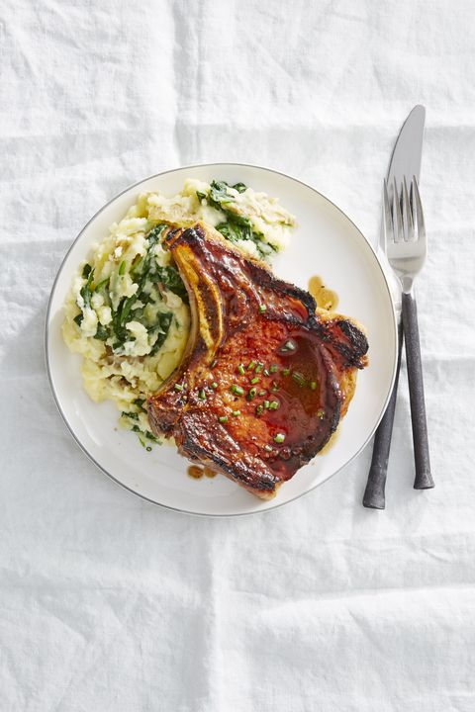

**Image source-** <https://www.goodhousekeeping.com/food-recipes/g333/pork-chop-recipes/?slide=1>

Take 1 pound of potatoes and pound and quarter them into a large pot. Add water to cover the vegetables and bring to a boil on high heat. Add a tablespoon salt, simmer the potatoes on medium heat until they are tender in 15 to 18 minutes.

Heat your broiler and place four pork chops on a rimmed baking sheet. Combine two tablespoons of brown sugar, ½ teaspoon salt and black pepper, and one tablespoon balsamic vinegar. Brush it over the pork chops. Broil the pork until cooked. Once the potatoes are tender, stir them in 5 ounces of baby spinach.

Return the veggies to the pot after draining. Add ½ tablespoon salt, ¼ teaspoon black pepper, and four tablespoons butter to the bowl and mash with potatoes. Serve with cooked pork.

**#7 Rosemary Truffle Sauce Pork Chops**

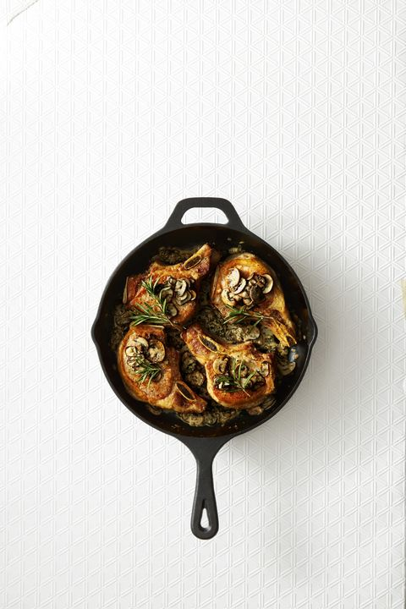

**Image source-** <https://www.goodhousekeeping.com/food-recipes/g333/pork-chop-recipes/?slide=1>

Take a 12-inch skillet. On medium-high heat, some oil until its very hot. Take your pork chops to the season with ½ teaspoon pepper and salt. Cook them for 6 minutes until they turn brown on both sides. Turn them over once and transfer them to a plate. Pour out the excess fat and reduce heat to medium.

To the skillet, add mushrooms, rosemary, 1/8 teaspoon salt, and shallots. Stir and cook for five minutes. Next stir in half and half butter. Nestle the pork in salt. Simmer for 4-6 minutes and serve once the pork is cooked.

**#8 Peppercorn Pork Chops**

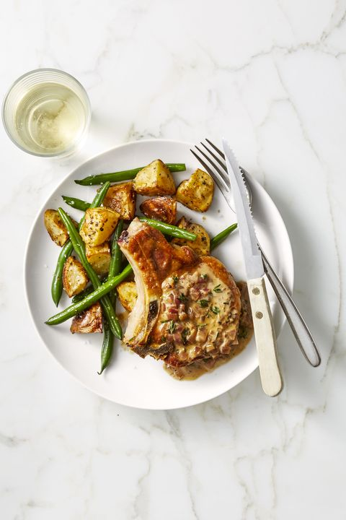

**Image source-** <https://www.goodhousekeeping.com/food-recipes/g333/pork-chop-recipes/?slide=1>

Take olive oil in a 12'' skillet and heat until it's hot. Season your pork chops with ½ tablespoon of salt. Add the pork skillet and cook for three minutes on each side, until the meat turns golden brown. Transfer it to a foil-lined rimmed baking sheet. Next, bake the preparation at 425 degrees F for ten minutes until the meat is cooked.

In the skillet, bring down the heat to medium-low. Add thyme and shallots. Stir and cook for two minutes. Whisk together pepper, mascarpone, white wine, and pinch salt. Simmer for two minutes while scraping up browned bits.

Serve the pork along with pan sauce, green beans, and roasted potatoes.

**#9 Asparagus Saute and Dijon Pork**

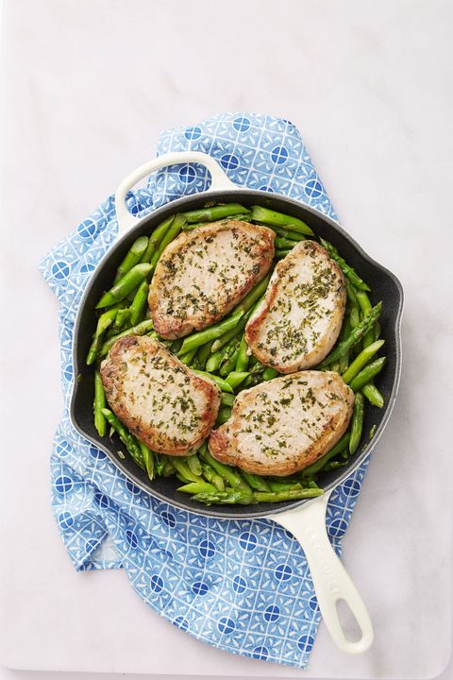

**Image source-** <https://www.goodhousekeeping.com/food-recipes/g333/pork-chop-recipes/?slide=1>

Rub both sides of your pork chop with tarragon leaves along with ½ teaspoon of salt. Take a 12-inch skillet and heat the olive until hot on medium-high. For the next five minutes, cook the pork until it’s brown on either side. Transfer it to the plate.

To the skillet, add asparagus as well as green onions. Cook them for the next three minutes, while stirring continuously. Add white wine and then simmer for the next two minutes. Stir in along with Dijon mustard. Nestle the pork into your asparagus. Cook for another 2-4 minutes until the pork is cooked through. Serve when ready.

**#10 Mustard Apricot Sauce Pork Chops**

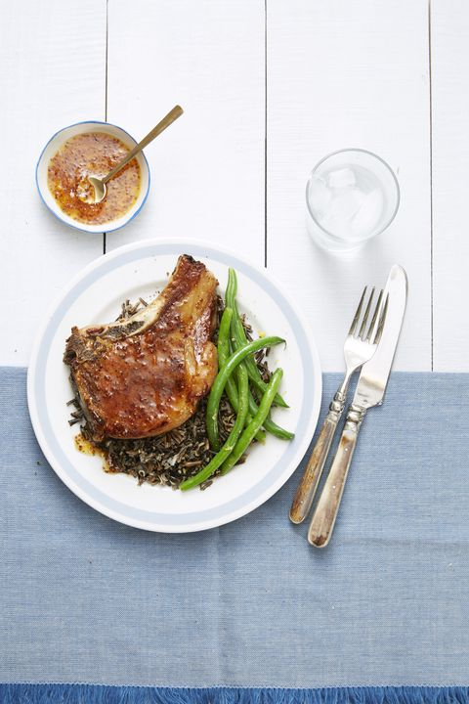

**Image source-** <https://www.goodhousekeeping.com/food-recipes/g333/pork-chop-recipes/?slide=1>

Cook your pork chops in the desired oil for 12 or 10 minutes. Keep the process on until the pork is cooked through at 145 degrees F. To the skillet, add broth, apricot jam, pepper, and mustard. Cook for three minutes while stirring and scraping.

Top your pork with mustard sauce. Serve when done with green beans and wild rice.

**#11 Lentil and Apple Salad Seared Pork Chops**

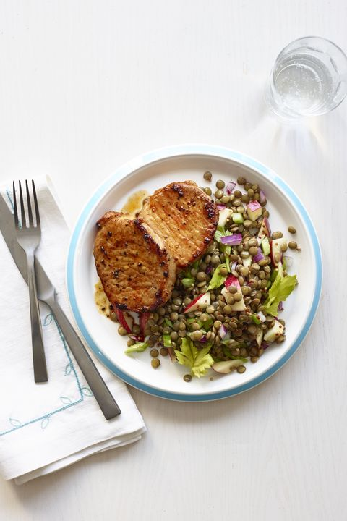

**Image source-** <https://www.goodhousekeeping.com/food-recipes/g333/pork-chop-recipes/?slide=1>

Take ½ tablespoon oil in a large-sized skillet and heat it in medium-high heat. Season your pork with paprika and ½ teaspoon each of pepper and salt. Cook four chops until they turn golden brown and are cooked through. This will take 2-3 minutes per each side. Repeat the process with ½ tablespoon oil with the remaining chops.

Take a tablespoon of oil, onion, mustard, vinegar, and ¼ tablespoon of pepper and salt. Add lentils to the mix and toss them to combine. Fold the mix along with apple, celery leaves, and celery. Serve with pork.

**#12 Apple Slaw with Rye Crusted Pork Chops**

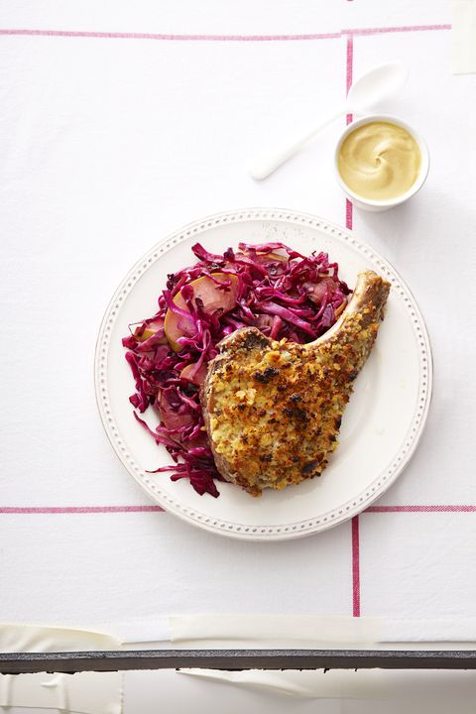

**Image source-** <https://www.goodhousekeeping.com/food-recipes/g333/pork-chop-recipes/?slide=1>

Take olive oil and torn rye bread in a processor and pulse them together. Season your pork chops with ½ teaspoon of pepper and salt and arrange them on an oiled baking sheet (rimmed). Top each pork chop with one teaspoon Dijon mustard and press on the rye crumbs.

Now, roast at 425 degrees F for 14-16 minutes. In a large skillet, heat butter on medium-high until it melts. To it, add apple, water, red cabbage, ¼ teaspoon salt, and water. Heat till it simmers and cook for 10 minutes. Serve once it’s wilted and soft.

**Conclusion**

Given above are some fantastic recipes that are easy to put together. If you want to eat healthily, there is nothing better than some pork chops. Make sure that you give these fantastic recipes a try!